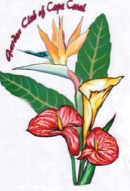

The Garden of Cape Coral
is pleased to offer
FUN WITH FLOWERS

Fee: $25.00 per session.
All materials necessary to create your beautiful flower arrangement will be provided.
To register for the September session, please send this form along with your check payable to GCCC, to P.O. Box 152022, Cape Coral, FL, 33915 no later than Friday prior to the Fun with Flowers session.
Classes will be held at the Fort Myers-Lee County Garden Council building, located at 2166 Virginia Avenue, Fort Myers, FL 33901.
Please indicate the session(s) you would like to attend;
_____ Friday, October 13, 2023 _____ Friday, March 15, 2024
_____ Friday, December 8, 2023 _____ Friday, April 19, 2024
Name: _____________________________________________________
Address: ___________________________________________________
Phone Number: _____________________________________________
Email: _____________________________________________________
If you have questions, please call Susan Lawson at 941-979-0615

Please join us for the fun!

