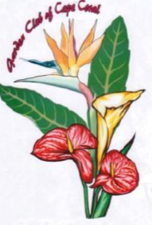

" MARCH IN THE PARK "
A JURIED PLANT & GARDEN ART SHOW

MARCH 9, 2024

The Garden Club of Cape Coral invites you to participate in the sixteenth annual juried vendor show on March 9, 2024 from 9 AM to 3 PM, at Jaycee Park in Cape Coral. The fee for a 10’ by 10’ space is $50 plus 10% of gross sales over $500 (an additional $25 for a 10’ x20’ space plus 10% of gross sales over $750). Vendor selection will be based on quality of merchandise and category limits to enhance sales potential.

Business Name______________________________________________

Contact Name_______________________________________________

Address__________________________________________________

Phone___________________________________________________

Email____________________________________________________

Description of items to be sold___________________________________

_________________________________________(use back if necessary)
Please return completed form and full description of merchandise, along with the appropriate fee by Feb 23, 2024 to: Garden Club of Cape Coral,
PO Box 152022, Cape Coral, Fl, 33915.

Checks can be made out to: Garden Club of Cape Coral
($25.00 charge for returned checks)

Any questions please contact: Ginny Huffer, Huffmom5@comcast.net, 239-257-2654

Don't forget to LIKE us on Face Book
Each vendor is required to donate an item of their choosing to the Garden Club, to be raffled off that day. THANK YOU

Organized 1997
Federated 1998 rain or shine 501c3

